PATTERN QUESTIONS

Pattern 1-flipped solid diamond

***** *****

**** ****

*** ***

** **

* *

* *

** **

*** ***

**** ****

***** *****

Sol= #include<iostream>

using namespace std;

int main()

{

int rowcount;

cout<<"enter the number of row "<<endl;

cin>>rowcount;

//for outer row

for(int row=0;row<rowcount;row++)

{

for(int col=0;col<rowcount-row;col++)

{

cout<<"*";

}

for(int col=0;col<2*row+1;col++)

{

cout<<" ";

}

for(int col=0;col<rowcount-row;col++)

{

cout<<"*";

}

cout<<endl;

}

for(int row=0;row<rowcount;row++){

for(int col=0;col<row+1;col++)

{

cout<<"*";

}

for(int col=0;col<2*(rowcount-1-row)+1;col++)

{

cout<<" ";

}

for(int col=0;col<row+1;col++)

{

cout<<"*";

}

cout<<endl;

}

}

Pattern 2-Hollow solid diamond

[https://mycareerwise.com/storage/editor/images/Hollow Star Diamond.png](https://mycareerwise.com/storage/editor/images/Hollow%20Star%20Diamond.png)

sol-#include<iostream>

using namespace std;

int main()

{

int rowcount;

cout<<"enter the number of row "<<endl;

cin>>rowcount;

//for outer row

for(int row=0;row<rowcount;row++)

{

for(int col=0;col<rowcount-row-1;col++)

{

cout<<" ";

}

for(int col=0;col<2*row+1;col++)

{

if(col==0||col==2*row)

{

cout<<"*";

}

else

{

cout<<" ";

}

}

cout<<endl;

}

for(int row=0;row<rowcount;row++){

for(int col=0;col<row;col++)

{

cout<<" ";

}

for(int col=0;col<2*(rowcount-1-row)+1;col++)

{

if(col==0||col==2*(rowcount-1-row))

{

cout<<"*";

}

else

{

cout<<" ";

}

}

cout<<endl;

}

}

Pattern 3-Inverted number of pyramids

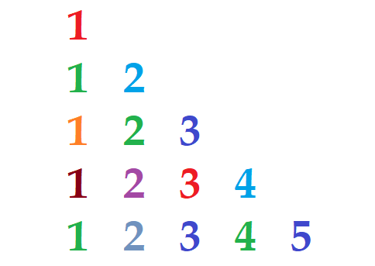

Sol-

#include<iostream>

using namespace std;

int main()

{

int rowcount;

cout<<"enter the numbmer of row "<<endl;

cin>>rowcount;

for(int row=0;row<rowcount;row++)

{

for(int col=0;col<row+1;col++)

{

cout<<col+1;

}

cout<<endl;

}

}

Pattern 4-Fancy pattern(numeric)

1

2*2

3*3*3

4*4*4*4

4*4*4*4

3*3*3

2*2

1

Sol-

#include<iostream>

using namespace std;

int main()

{

int rowcount;

cout<<"enter the numbmer of row "<<endl;

cin>>rowcount;

for(int row=0;row<rowcount;row++)

{

for(int col=0;col<2*row+1;col++)

{

if((col%2)==0)

{

cout<<row+1;

}

else

{

cout<<"*";

}

}

cout<<endl;

}

for(int row=0;row<rowcount;row++)

{

for(int col=0;col<2*(rowcount-1-row)+1;col++)

{

if((col%2)==0)

{

cout<<rowcount-row;

}

else

{

cout<<"*";

}

}

cout<<endl;

}

}

Pattern 5-Pallindrome alphabet pyramid